**PickUp Sports**

Iris Lamb

Jarrod Jablonski

William Woods

**TABLE OF CONTENTS**

**Project Charter** **5**

**Purpose (Project Objectives)** **5**

**Project Description** **5**

Project History. 5

Scope of this Project. 5

**Project Environment.** **6**

Project Participants. 6

Problems and Opportunities. 6

Project Constraints. 6

Project Vision. 6

**Preliminary Findings and Analysis.** **6**

**Preliminary Solutions and Ideas.** **7**

**Project Schedule.** **7**

Week 1 (January 28th - February 3rd) 7

Week 2, 3, and 4 (February 4th - February 24th) 8

Week 5, 6, and 7 (February 25th - March 17th) 8

Week 8, 9, and 10 (March 18th - April 7th) 8

Week 11, 12, and 13 (April 8th - April 30th) 8

**Project Budget.** **9**

**Project Documentation and Communication.** **9**

**Project Report** **10**

**Project Scope.** **10**

**Current system or situation** **10**

Background Objectives and Scope 10

Operational Policies and Constraints 10

Description of Current System or Situation 11

Users or Involved Personnel 12

Support Concept 12

**Justification for and nature of changes.** **12**

Justification for change. 12

Description of needed changes. 13

Priorities among the changes. 13

Changes considered but not included. 14

Assumptions and constraints. 14

**Concept for a new or modified system.** **14**

Background, objectives, and scope. 14

Operational policies and constraints. 14

Description of the new or modified system. 14

Users/affected personnel. 15

Support concept. 15

**Operational scenarios.** **15**

**Summary of impacts.** **15**

Operational impacts. 15

Organizational impacts. 15

Impacts during development. 16

**Analysis of the proposed system.** **16**

Summary of advantages. 16

Summary of disadvantages/limitations. 16

Alternatives and trade-offs considered. 16

**Project Plan** **17**

**System Requirements** **18**

**Scope** **18**

**Requirements.** **18**

System capability requirements. 18

Required states and modes. 18

System external interface requirements. 18

Interface identification and diagrams. 18

System internal interface requirements. 19

System internal data requirements. 19

Adaptation requirements. 19

Security and privacy requirements. 19

System environment requirements. 19

Computer resource requirements. 19

Computer hardware requirements. 19

Computer software requirements. 19

System quality factors. 19

Design and construction constraints. 20

Personnel-related requirements. 20

Training-related requirements. 20

Logistics-related requirements. 20

Other requirements. 20

Packaging requirements. 20

Precedence and criticality of requirements. 20

**Qualification provisions.** **21**

**Description of the new or modified system.** **21**

**Notes.** **22**

**Test Plan.** **22**

Project Unique identifier for test 22

Hardware preparation. 22

Software preparation. 22

Other pretest preparations. 22

Prerequisite conditions. 22

Test inputs. 22

Expected test results. 23

Criteria for evaluating results. 23

**System Design****.** **25**

Scope. 25

System Architectural design. 25

Logical Model. 25

Database Overview. 26

Detailed design of the database & Data Schema Diagram. 27

Process/Behavioral Design. 28

Functional Decomposition Model. 28

Sequence Diagram. 29

Activity Diagram 30

Screen Prototype. 31

# **Project Charter**

# Purpose (Project Objectives)

* 1. The purpose of the PickUp Sports project is to create a mobile application that will allow a user to pick a location and sport to play and have it publicly listed so anyone can participate in that activity.

# Project Description

## Project History.

* + 1. This project came about because of the numerous times that a group of people want to go play some type of sports game but having trouble doing so simply because there isn’t enough players.

## Scope of this Project.

* + 1. The purpose of this project is to allow the user to be able to join, or start, a pick-up sport of his or her choosing. The client will sign in into the mobile application with a username and then create or join a game by tapping the sport and/or location that they would like to play. They will then receive a confirmation screen showing which court or field to join the other users for a pick up game, or get an email when others sign up to play. The court(s) will be identified and numbered based on the field research that will be conducted.
    2. This project’s scope does not include any form of payments. It will be a completely free application for the users. It will also not have in depth personal profiles. While a simple profile is necessary for a chat feature, their will not be avatars or bios included. It is also only limited to Illinois State University students. This will limit the proximity of locations available to view in the application.

# Project Environment.

## Project Participants.

* + 1. Management
       1. Jarrod Jablonski, Project Lead
       2. Iris Lamb, Business Analyst/Project Team member
       3. William Woods, Software Engineer/Project Team Member
    2. Non-Management
       1. Rishi Saripalle, Client

## Problems and Opportunities.

* + 1. If an event has it’s details changed in any way, how will word get out to those who are registered? - We hope to be able to send a message to all who are signed up to inform them of what has changed. There is also no way to ensure that all students will be using this application. That will lead to possible scheduling issues that could not have been predicted without everyone’s involvement.
    2. PickUp Sports has a great opportunity of bringing the community of Illinois State students together. It will increase physical activities which helps the user have a healthy social life.

## Project Constraints.

* + 1. The general area of the application will be limited to the Bloomington-Normal Area

## Project Vision.

* + 1. We expect to have an application that is easy to use, and will promote public activities

# Preliminary Findings and Analysis.

* 1. A major issue that we will be facing is our team’s skillset. Although we possess some programming knowledge, as a team Android Studio is not a program that we have a lot of experience with. It has been a lot of trial and error to reach successful outcomes thus far. Another problem that we have encountered is validating the locations. There is no sure way for our program to check and validate hat the locations inputted by the users are real and usable. Once an event is created, it leads to yet another issue that is difficult to solve. We have no way to know that the event is actually taking place and that all members are showing up. It is expected that a user will notify the other event members that they will not be showing up, but it is completely on an honor code.
  2. There are a few opportunities that come from the development of this application. It brings a sense of community together. It allows students to come together for healthy and wholesome interactions through a passion of sports. It also gives students another healthy alternative activity to engage in on the weekends. As opposed to sitting inside and playing video games, it gives them a chance to have healthy interactions with others.
  3. The basic schedule of this project will be 4 deliverables, roughly 1 every 2-3 weeks, and a demonstration of the final project towards the end of April.

# Preliminary Solutions and Ideas.

* 1. Create a user friendly mobile application that allows people to easily view any pick up sport event that is or will be happening within the next couple of days. Also, allow for anyone to create an event, and filter through the pick up sport events by their names, and location.

# Project Schedule.

## Week 1 (January 28th - February 3rd)

* + 1. Project Charter

**Deliverable**: Project Charter Presentation (February 4th)

## Week 2, 3, and 4 (February 4th - February 24th)

* + 1. Project Team Meetings
    2. Initial Research
    3. Field Research
    4. Gather Resources
    5. Preparation of Study Report
    6. Review of Documentation

**Deliverable**: Study Report Presentation (February 25th)

## Week 5, 6, and 7 (February 25th - March 17th)

* + 1. Project Team Meetings
    2. Finalizing Research
    3. Project System Sketch
    4. Preparing System Requirements Documentation
    5. Review of Documentation

**Deliverable**: System Requirements Presentation (March 18th)

## Week 8, 9, and 10 (March 18th - April 7th)

* + 1. Project Team Meetings
    2. Reviewing of Application Sketch
    3. Initial Coding/Debugging
    4. First Prototype
    5. Preparing System Proposal Documentation

**Deliverable**: System Proposal & Design Presentation (April 8th)

## Week 11, 12, and 13 (April 8th - April 30th)

* + 1. Project Team Meetings
    2. Reviewing Prototype
    3. Finalizing Coding/Debugging/Testing
    4. Finalizing Application
    5. Preparing Final System Documentation

**Deliverable**: Final System Presentation (May 1st)

# Project Budget.

* 1. 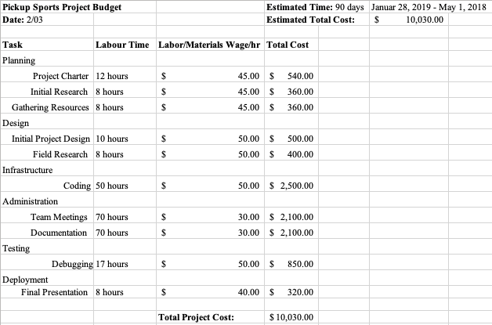

# Project Documentation and Communication.

* 1. The team communication relies on group messages via GroupMe
  2. The documentation are shared and stored using Google Docs
  3. Weekly meeting are planned for Thursday evenings

# **Project Report**

# Project Scope.

* 1. The purpose of this project is to allow the user to be able to join, or start, a pick-up sport of his or her choosing. The client will sign in into the mobile application with a username and then create or join a game by tapping the sport and/or location that they would like to play. They will then receive a confirmation screen showing which court or field to join the other users for a pick up game, or get an email when others sign up to play. The court(s) will be identified and numbered based on the field research that will be conducted.
  2. This project’s scope does not include any form of payments. It will be a completely free application for the users. It will also not have in depth personal profiles. While a simple profile is necessary for a chat feature, their will not be avatars or bios included. It is also only limited to Illinois State University students. This will limit the proximity of locations available to view in the application.

# Current system or situation

## Background Objectives and Scope

* + 1. The current system that we are trying to improve is the mobile application OpenSports - Pickup Sports available through Google Play. It connects the user to players and sports in the neighborhood they are in so all they have to do is “come out and play.” It allows the user to make a profile, chat with other players, browse upcoming games as well as manage your own upcoming games in a queue.

## Operational Policies and Constraints

* + 1. There are limited constraints to the OpenSports application. Only group administrator can send out announcements to group members as opposed to just any user. It also requires the 4.2 version of Android and up and cannot be downloaded on Apple products.

## Description of Current System or Situation

* + 1. The current system is being developed solely for Illinois State University students. These students will have a resource to meet one another by joining time slots to play sports as a group.
    2. In order to develop this system, we want to create its functionality based around Illinois State’s provided emails. This will help ensure a level of safety that not any person can join the application. This will all be made possible through Android Studio. We also want to add a notification feature for our users. This will aid in any confusion of games being cancelled among group members or notify the user when it is the next group’s turn to use the location.
    3. From the reviews, this application is very user friendly and convenient to use. You create your own profile and can customize your player cards for each individual sport played. After a profile is created, the user can browse upcoming sports. There are options for substitute positions, full-time positions plus free and paid activities. The users can chat with one another and set up polls to find out what game would be best for everyone to play that they are chatting with. Each user gets their own queue of games that they have signed up with so they are easy to manage. When hosting a game, they can invite specific players to join and manage who is included.
    4. From our research this is a very reliable and efficient application. Its maintenance is very minimal. There are a few issues that users have been having. One person was getting an error message when trying to join a group and send messages. Tech support is very quick to respond to any issues written in. A user must email [contact@opensports.net](mailto:contact@opensports.net) to have their problem dealt with.
    5. When downloading the OpenSports application, they access a lot of content on the user’s mobile device. They have the right to read calendar events plus “confidential information”. It also can add or modify calendar events and send email to guests without owners' knowledge. On their permissions listing it also states that they have the right to “read the contents of your USB storage and modify or delete the contents of your USB storage”. There are a few other standard permissions that come with downloading it that are not concerning.

## Users or Involved Personnel

* + 1. 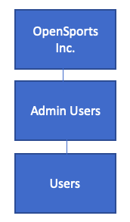

## Support Concept

* + 1. PickUp Sports is being created using Android Studio. Git allows us to easily share our work with one another.

# Justification for and nature of changes.

## Justification for change.

* + 1. OpenSports is a very helpful mobile application for Android users, but there are some changes that our application, Pickup Sports, will have that will help improve it. Although OpenSports is open to for the public, admin users have the capability of picking and choosing who will be in their game. They can invite certain users and deny others from joining. We do not like the idea of being able to exclude certain users from events when there is still more people needed. The application also has a lot of access to the user’s data that is unnecessary. They should not be able to delete and change items on the user’s phone without their knowledge of it. Since it is open to the entire public, that also raises a huge safety concern.
    2. PickUp Sports is limited to Illinois State students, but among the those users there will be no function to pick and choose who gets to join a game. It will be based off of a first come first served policy which is the fairest way to have it. Having it limited to Illinois State University students helps us add a safety aspect to it. The application will also not be able to gather any data from the user’s phone. Since we have it limited to the Illinois State University area, there is no need for the application to be able to access the user’s location.
    3. Our priority among the changes is getting rid of the exclusivity aspect. We find it very important to allow all users to have equal opportunity to play and enjoy the point of the mobile application. Our only exclusion quality is that only Illinois State University students have access to it. It is desirable that the application does not access unnecessary information on the user’s device.

## Description of needed changes.

* + 1. The change that needs to happen is to create an application for ISU students to be able to find a pickup game of any sport, and opt in to play for free. There also needs to be a nice UI, and some sort of communication be available so all participants can stay informed.

## Priorities among the changes.

* + 1. The most important change is the creation of the an application solely for Illinois State students. The essential changes, listed in order of importance, are for the user to be able to find any game, be able to opt into said game, and have some sort of communication be available. A desirable change would be to have a nice UI, and an optional change is for it to be free.

## Changes considered but not included.

* + 1. The main change that was considered but not included is the implementation of having real time chat for every pick up event. The reason for this is that it would take too long to create and have implemented into every event before the deadline.

## Assumptions and constraints.

* + 1. Because this is a unique application the main assumption we are making is that we will not come across any unexpected constraints or roadblocks.

# Concept for a new or modified system.

## Background, objectives, and scope.

* + 1. At the moment, there is a concept for ISU student to be able to play recreational sports via a online sign-up but with a different objective than the PickUp Sport application . What the objective is for this application is for any capable ISU student to be able to sign up and join other students in the sport of their choosing for free. The application won’t require the user to have a team of people or money in order to fulfill a spot.

## Operational policies and constraints.

* + 1. With the amount of time that is left to complete this project. We find ourself limiting certain features out of the application such as a real time chat system. Though it would prove to be very useful in allowing the user to communicate with each other after joining a queue, to develop said system would take more time then what we have. Most of the main concepts of the application still remain intact.

## Description of the new or modified system.

* + 1. The PickUp Sport Application will allow the user to sign up for a sport of their choosing. Then the user will receive a confirmation screen with the location of where the sport that they have chose for the pickup game.

## Users/affected personnel.

* + 1. The developers are responsible for creating a stable application that allows users to coordinate a pickup game with a sport of their choosing. They will also send the users a confirmation via the application and/or email to notify the user of the status of the pickup game that they may have created or signed up for. The user is responsible for picking a time and location that they would like to play a pickup game. The users can communicate via email to discuss specifics. The user is also responsible for equipment used for the game as well transportation to the recreational location.

## Support concept.

* + 1. The application will be built and demoed via Android Studio. Any changes or modifications will take place on Android Studio. The developers are not responsible for providing any equipment for the pickup games.

# Operational scenarios.

* 1. The role of this new application is intended to engage the community through sports. Any person will be able to find a pick up sport event they are interested in, opt in to participate in that event, and be able to be in some sort of communication with others who may have opted in. A pick up sport event can be created by anyone, and there will be a maximum number of events scheduled at once, per location (number of events is different per location).

# Summary of impacts.

## Operational impacts.

* + 1. After deployment of the application we will send patch notes to all of our users so they can stay informed about what the app has to offer. The users will be constantly changing because students only have access to their ilstu email accounts six months post-graduation.

## Organizational impacts.

* + 1. There will be no training required.

## Impacts during development.

* + 1. We will have weekly meetings to discuss the development of the application, and there will be many tests conducted to ensure the app works as intended. One specific impact that may occur during development is our notification method. It is our intent to have notifications be sent through the mobile application itself. If this ends up not being possible, we are going to try email based notifications instead.

# Analysis of the proposed system.

## Summary of advantages.

* + 1. The advantages of this new application will be increased community health and involvement.

## Summary of disadvantages/limitations.

* + 1. There are a few disadvantages that will come with the development of this application. We will be unable to check and manage teams leaving an event spot at the correct time. There is also no way for us to ensure that the spots will be available at the desired times. It could be used by players that do not use the app. Another limitation that we will encounter is making sure that the rules of the location are being followed.

## Alternatives and trade-offs considered.

* + 1. The alternatives considered with this application are mainly centered around the limitations. Originally we were going to be focused on the Normal, IL area but due to the allotted time we are focusing on Illinois State University students on the ISU campus.

# Project Plan

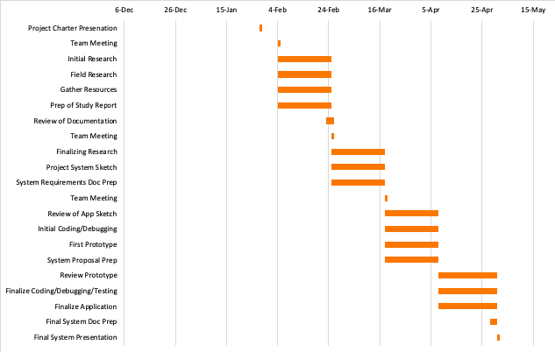

# **System Requirements**

# Scope

* 1. The purpose of this project is to allow the user to be able to join, or start, a pick-up sport of his or her choosing. The client will sign in into the mobile application with a username and then create or join a game by tapping the sport and/or location that they would like to play. They will then receive a confirmation screen showing which court or field to join the other users for a pick up game, or get an email when others sign up to play. The court(s) will be identified and numbered based on the field research that will be conducted.
  2. This project’s scope does not include any form of payments. It will be a completely free application for the users. It will also not have in depth personal profiles. While a simple profile is necessary for a chat feature, their will not be avatars or bios included. It is also only limited to Illinois State University students. This will limit the proximity of locations available to view in the application.

# Requirements.

## System capability requirements.

* + 1. 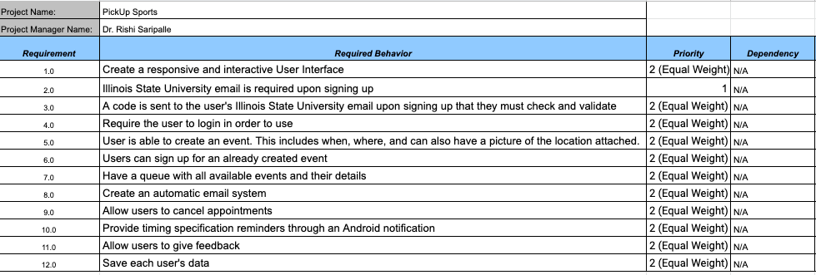

## Required states and modes.

* + 1. Our system will only be required to operate in one state, which is the normal state. The normal state is the only mode our system will be required to operate in. This state will consist of only our 12 requirements, listed above, and nothing more.

## System external interface requirements.

## Interface identification and diagrams.

* + - 1. There is one piece of data required within the interface and that is the email address being an Illinois State University one. Upon signing up, if the user does not use an email address that ends in @ilstu.edu then they will not receive a confirmation code. If they do not receive a confirmation code then they cannot follow through with signing up to use the mobile application. Other than this, no specific data will be required because we are not filtering the inputs of the users when making sporting events.
      2. Requirement: Create login
         1. String - Email
         2. Constraint - Security - @ilstu.edu
      3. Requirement: Create Event
         1. String - Location
         2. Constraint - N/A
      4. Requirement: Allow User Feedback
         1. String - Comments
         2. Constraint - N/A

## System internal interface requirements.

* + 1. All interfaces are left to the design specifications

## System internal data requirements.

* + 1. The only data requirements will be that all users have an Illinois State University email associated with their account.

## Adaptation requirements.

* + 1. There will be no installation-dependent data that the system is required to provide

## Security and privacy requirements.

* + 1. One of our requirements for PickUp Sports is requiring an Illinois State University email in order to sign up. This will help maintain a lot of security for the users because they will know that they are meeting one of their fellow peers. With the OpenSports mobile application that we are basing ours off of, anyone could join without any certain requirements. This can be a huge risk factor because it is not as easy to trace who someone is if something was to go wrong during an event.

## System environment requirements.

* + 1. PickUp Sports is a mobile application that can only be run on Android. We are developing the app using Android Studio so the only requirement is that the user must be operating a Google Android device in order to access the application.

## Computer resource requirements.

## Computer hardware requirements.

* + - 1. Being that this application is being developed on Android Studio, the user must be operating an Android device to run it.

## Computer software requirements.

* + - 1. Being that this is an Android application, the user must have access to Google Play in order to download or have had it directly sent to them by someone who has access to the application. We have not decided if it will be on any websites for other chances to access.

## System quality factors.

* + 1. We are expecting that this application will require minimal maintenance after it has been deployed. If need be, all of our team members have quick and easy access to the source code to diagnose and repair the issue at hand. Its availability is great as long as the user is an Illinois State University student and has an Android device. In the future, it can be re-designed to make it available to Apple users as well and make it publically available to all.

## Design and construction constraints.

* + 1. This software is very basic which leads us to believe that we will not have any issues with it being downloaded on newer systems in the future. All characteristic constraints are dealt with automatically since it is developed in Android Studio. This mobile application is very flexible to Android users because it can be downloaded straight from the Google Play application store which comes on every Android device. Other than that we can send it directly to a user or even make it available straight through one of Illinois State’s websites.

## Personnel-related requirements.

* + 1. Any Illinois State University student with a mobile Android device will have access to this application. Although we are working with college students, the likelihood of human error is very possible since we are allowing the users to create their own events. We are not imposing any types of filters when it comes to inputting details of the sporting events. This can lead to inappropriate or false information to be inputted and made into an event.

## Training-related requirements.

* + 1. There are no training-related requirements that come with the use of the PickUp Sports mobile application.

## Logistics-related requirements.

* + 1. PickUp Sports should require little to no maintenance after its launch. It will be a self-sufficient mobile application.

## Other requirements.

* + 1. All system requirements have been covered

## Packaging requirements.

* + 1. Android Studio has a number of steps that should be taken in order to give a final release. We must configure the application which means removing any Log calls and the android:debuggable attribute from the manifest file. Then the Gradle build files will most likely be used to build and release the exact version that we want. It will then be tested on a designated tablet and handset device. Once this is all done, we will finally have a .apk file that we can distribute to users.

## Precedence and criticality of requirements.

* + 1. Among all of our requirements, they are all of equal weight except for needing an Illinois State University provided email in order to sign up. This requirement is more critical than the rest because it is our only safety aspect that we are providing to our users.

# Qualification provisions.

* 1. 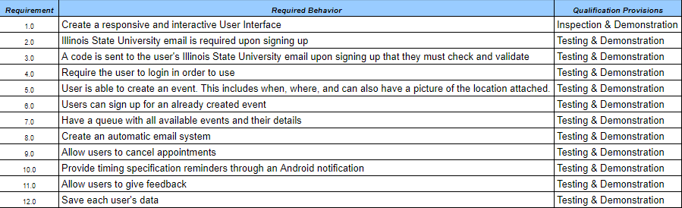

# Description of the new or modified system.

* 1. The PickUp Sport Application will allow any Illinois State University student to sign up for a sport of their choosing, then the user will receive a confirmation screen with the location of the event that they have chosen to partake in. The user will receive emails with any updates regarding any event they are signed up for and at any point they will be able to opt out of any event.
  2. 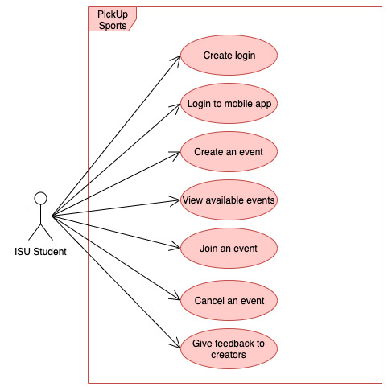

# Notes.

* 1. N/A

# Test Plan.

## Project Unique identifier for test

## Hardware preparation.

* + - 1. There will not be any hardware preparation as this application is not resource intensive and anything that can run Android Studio will work.

## Software preparation.

* + - 1. The only software preparation we will need is to have Android Studio available for us to use on a desktop or laptop to run tests and make changes to the app.

## Other pretest preparations.

* + - 1. There will be no pretest preparations required

## Prerequisite conditions.

* + - 1. There will be no prerequisite conditions needed prior to performing the test case

## Test inputs.

* + - 1. The main tests we will need to perform will be functionality tests, ensuring everything is working (navigating to another page, signing up for an event, sending updates to an event, etc…)

## Expected test results.

* + - 1. The expected result is that everything works as it is functionally supposed to (the correct page shows when swapping, the user is actually added to the event when they sign up, and the user gets all updates when an event has something changed, etc…)

## Criteria for evaluating results.

* + - 1. The range or accuracy over which an output can vary and still be acceptable
         1. The final test case will have a user that is able to sign up for an event, get all notifications the event sends out, and be able to opt out of an event
      2. Minimum number of combinations or alternatives of input and output conditions that constitute an acceptable test result
         1. The only acceptable test results will be full functionality
      3. Maximum/minimum allowable test duration, in terms of time or number of events
         1. The testing period will be available until May 2nd, when the project is due.
      4. Maximum number of interrupts, halts, or other system breaks that may occur
         1. Due to limited time, no interrupts will be acceptable.
      5. Allowable severity of processing errors
         1. Due to the relatively low complexity of the application, no processing errors will be allowed.
      6. Conditions under which the result is inconclusive and retesting is to be performed
         1. Due to the relatively low complexity of the application, the tests will either work or they won’t so retesting should not be needed.
      7. Conditions under which the outputs are to be interpreted as indicating irregularities in input test data, in the test database/data files, or in test procedures
         1. Due to the relatively low complexity of the application, all test results should be straight forward
      8. Allowable indications of the control, status, and results of the test and the readiness for the next test case (may be output of auxiliary test software)
         1. Once a user is able to sign up for an event and receives notifications from the event, we will be able to move into adding extra features to the application
      9. Additional criteria not mentioned above.
         1. N/A

**System Design**

1. Scope.
   1. The purpose of this project is to allow the user to be able to join, or start, a pick-up sport of his or her choosing. The client will sign in into the mobile application with a username and then create or join a game by tapping the sport and/or location that they would like to play. They will then receive a confirmation screen showing which court or field to join the other users for a pick up game, or get an email when others sign up to play. The court(s) will be identified and numbered based on the field research that will be conducted.
   2. This project’s scope does not include any form of payments. It will be a completely free application for the users. It will also not have in depth personal profiles. While a simple profile is necessary for a chat feature, their will not be avatars or bios included. It is also only limited to Illinois State University students. This will limit the proximity of locations available to view in the application.
2. System architectural design.
   1. Data Design.
      1. Logical Model
         1. 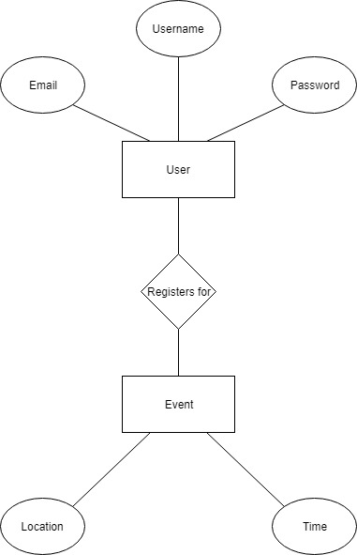
            1. The above E/R diagram describes how the user and their attributes interact with the events that have been created within the database.
      2. Database overview.
         1. Pickup Sports has been a work in progress since January of 2019. With the help of our sponsor, Rishi Saripalle, we were able to agree upon a set of requirements that we have been incorporating into this mobile application. The developers, William Woods, Jarrod Jablonski, and Iris Lamb have been designing PickUp Sports so that Illinois State University students can have a healthy way of interacting. After its launch, the application will have little to no maintenance required. The user can sign up and create sporting events in which other users can view and join.

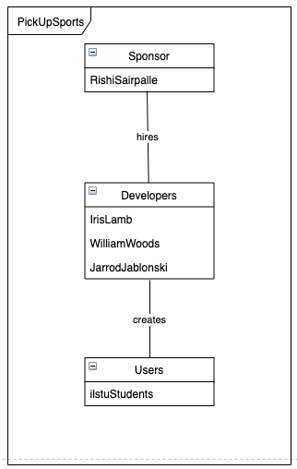

* + 1. Detailed design of the database. Data Schema Diagram.
       1. A PickUp Sports event requires the name of the sport, the location of the event, the time of the event, and players. In order to be a user the person must have an Illinois State University email address, a password, and provide their name. The User Account uses Pick Up Events in order to achieve the purpose of the application, playing a sport with other students. 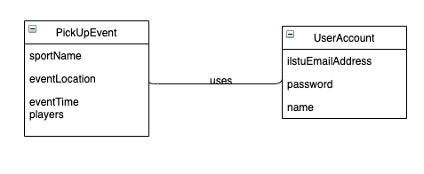
  1. Process/Behavioral Design.
     1. Process Specifications (equivalent UML diagram).
        1. Process specifications are not created for physical input and/or output processes or processes that represent simple data validation. PickUp Sports only requires email validation. It also has simple inputs of event details made by the users so it does not apply.
  2. Functional Design.
     1. Functional Decomposition Model
        1. 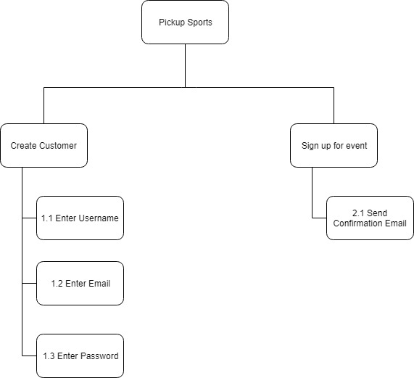
           1. The above model is the description of the actions that are taken within the database
     2. Sequence Diagram
        1. 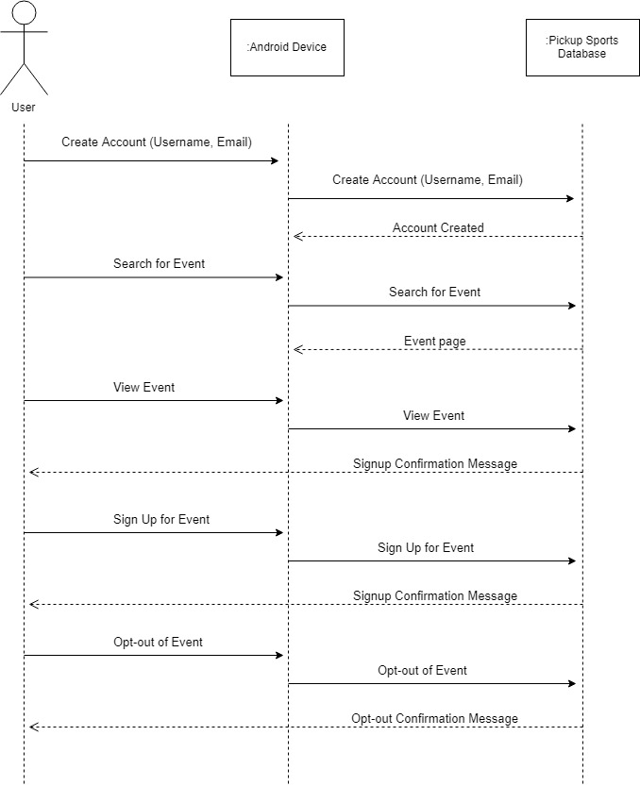
           1. The above Sequence Diagram helps describe the actions that are taken within the database
     3. Activity Diagram
        1. 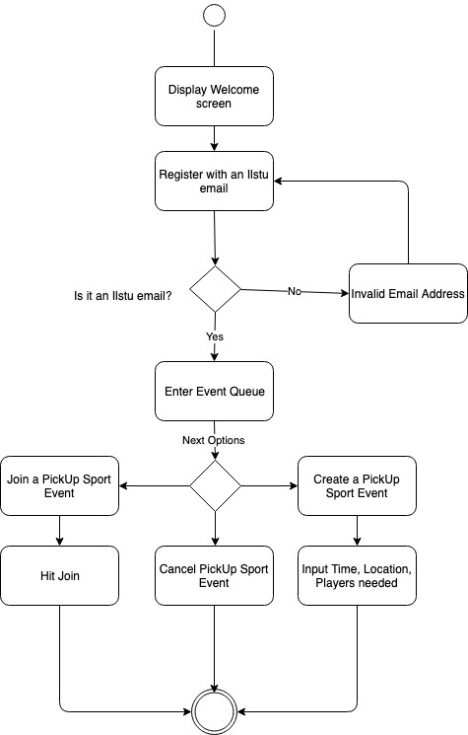
           1. The above activity diagram explains the decisions that the user has to go through while using the PickUp Sports mobile application.
  3. Screen Prototype.
     1. External Interface Design
        1. 
        2. 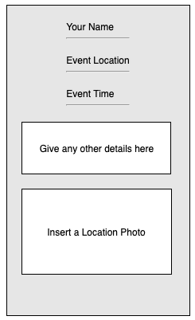
        3. 